IARSS COMPLIANCE SYSTEM – QUICK START GUIDE

LOG IN
In order to receive access to the Compliance System, you must first contact Susan Sarfaty at ssarfaty@stclair.k12.il.us Once access has been granted, you will receive an invitation email from the IARSS Compliance System. Follow that link to sign in and set your password.
Once you have set your password, you can log into the system by going to iarss.org and clicking on the Services drop down and then clicking on Compliance.
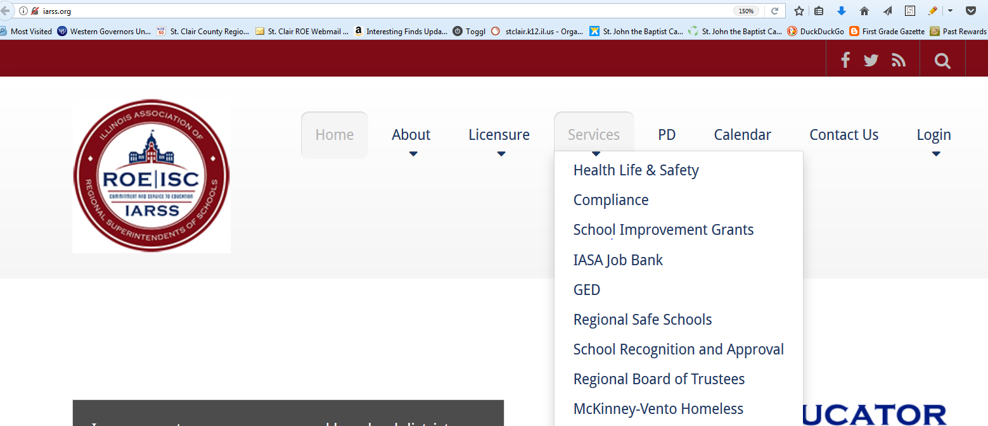

Next click on the ROE/District login for Compliance System and sign in with your Email Address and the password that you created via your invitation.
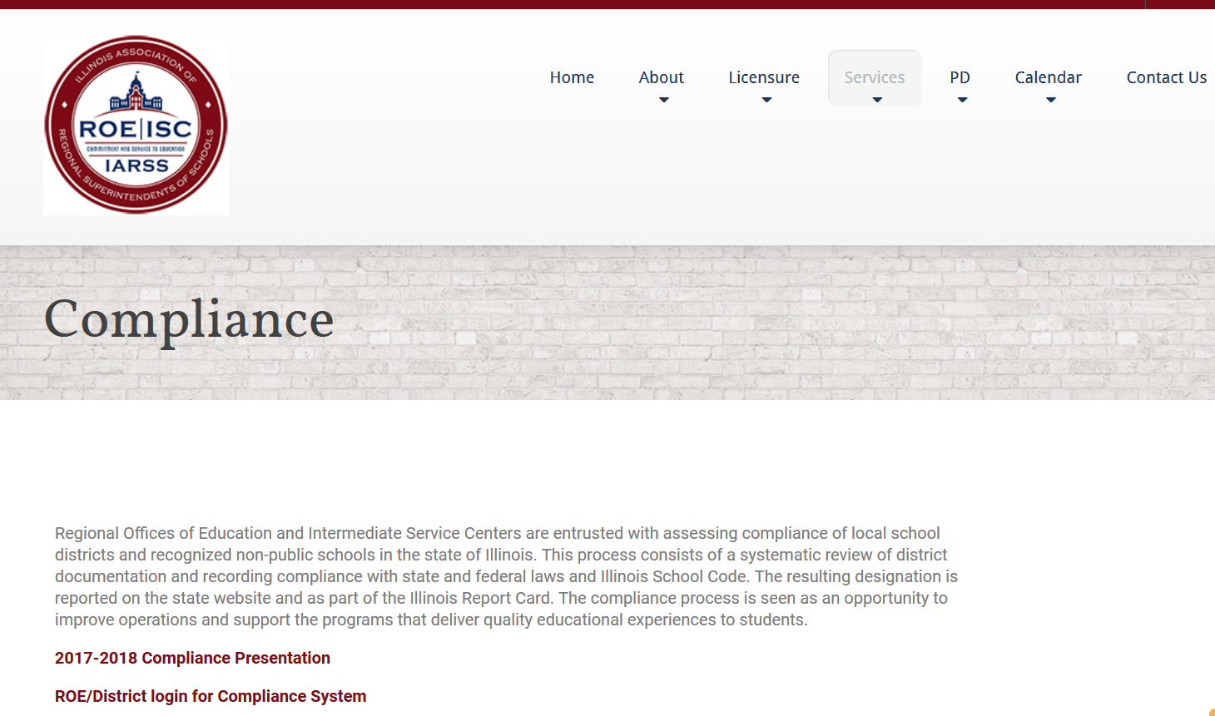

ADDING A DOCUMENT
- Click on your district name.
- Click on the section in which you want to add a document.

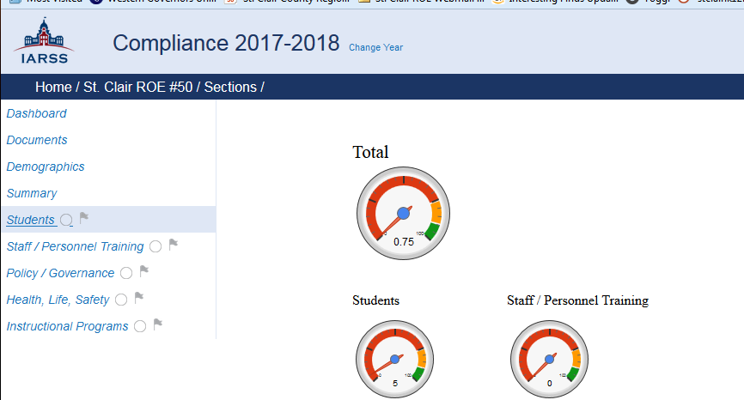

- Click on Add a Document or Website.
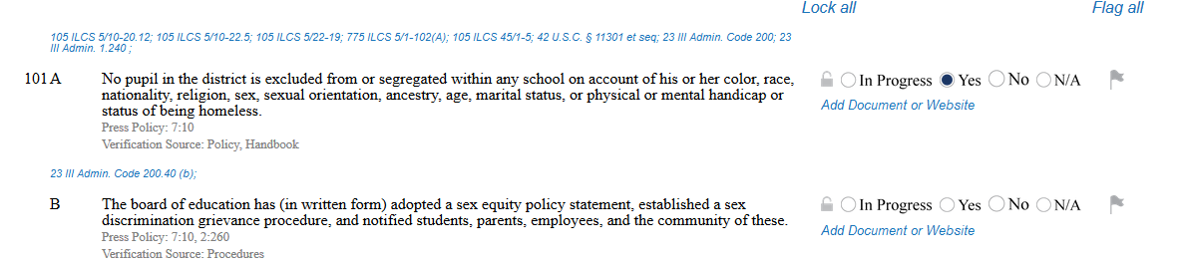

- A list of documents that have already been added will show in the list. You can click to choose one of these or click on Browse to add a new document. This will open a window that will allow you to choose a document. ( Please note the ROE will only accept the following document types. .docx, .xlsx, and .pdf ). Select a file and click Open.
- Once you have selected a document it will show next to the Browse button. Click on submit to add the document to the question.
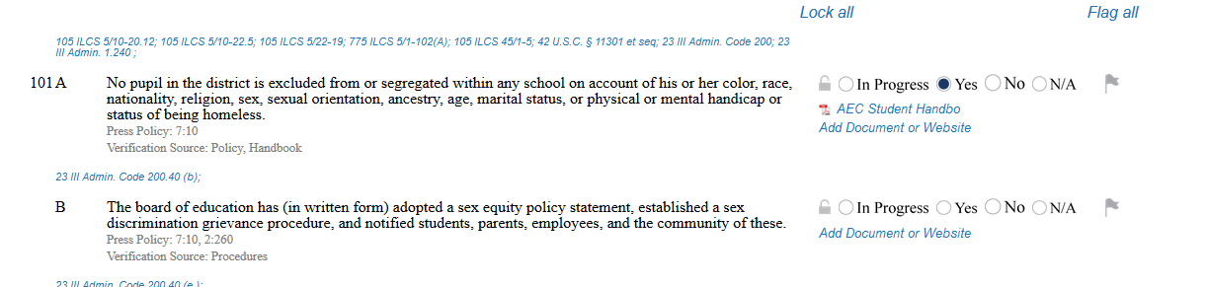

- If you want to remove the document from a question, click on the Add Document or Website link for that question and then uncheck the box next to the document you want to remove.
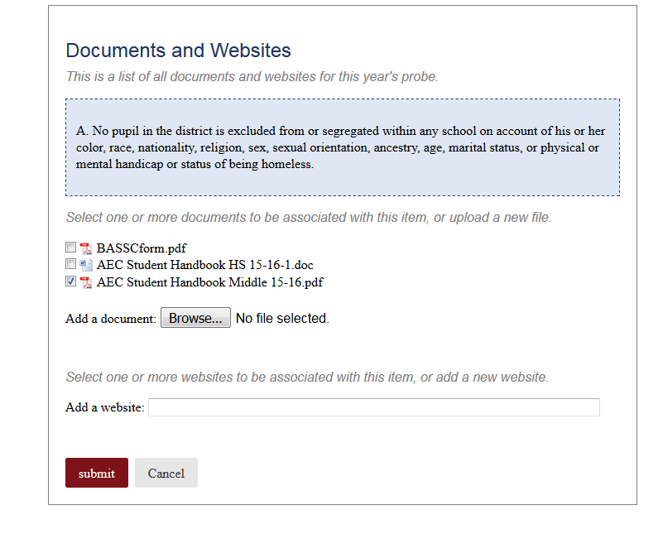
- Removing a document from a question will not remove the document from the system. If you want to remove a document from the system, you need to go to the Documents section, select the file you want to remove from the list, and click on delete.

COMMENTS
Comments can be added to any section. Those comments are permanent and a running list of all comments will be kept by the system.

FLAGGING/UN-FLAGGING
In each section there is a place where you can flag a question. You can select flag all to flag all the questions in the section or you can click on each flag individually. Note, if you click to flag all, you will need to click on each flag individually to un-flag them.

SEARCHING
You can click the search button at the top of each section to search the compliance documentation.

